

**Web Base Tire Sales Management System**

Name: Walpita Gamage Thilina Thushantha

Index No: 17032498

London Metropolitan University

2018 March

**Declaration**

**Module : FC6P01 Deadline : Sunday, 9th November 2018**

**Module Leader : Dr. Richard Walters Student ID : 17032498**

Plagiarism

You are reminded that there exist regulations concerning plagiarism. Extracts from these regulations are printed below. Please sign below to say that you have read and understand these extracts:

(signature:)______________________ Date: 18/11/18

This header sheet should be attached to the work you submit. No work will be accepted without it.

Extracts from University *Regulations* onCheating, Plagiarism and Collusion

Section 2.3: "The following broad types of offence can be identified and are provided as indicative examples…

1. Cheating: including taking unauthorised material into an examination; consulting unauthorised material outside the examination hall during the examination; obtaining an unseen examination paper in advance of the examination; copying from another examinee; using an unauthorised calculator during the examination or storing unauthorised material in the memory of a programmable calculator which is taken into the examination; copying coursework.
2. Falsifying data in experimental results.
3. Personation, where a substitute takes an examination or test on behalf of the candidate. Both candidate and substitute may be guilty of an offence under these Regulations.
4. Bribery or attempted bribery of a person thought to have some influence on the candidate's assessment.
5. Collusion to present joint work as the work solely of one individual.
6. Plagiarism, where the work or ideas of another are presented as the candidate's own.
7. Other conduct calculated to secure an advantage on assessment.

(viii) Assisting in any of the above.

Some notes on what this means for students:

1. Copying another student's work is an offence, whether from a copy on paper or from a computer file, and in whatever form the intellectual property being copied takes, including text, mathematical notation and computer programs.

2. Taking extracts from published sources *without attribution* is an offence. To quote ideas, sometimes using extracts, is generally to be encouraged. Quoting ideas is achieved by stating an author's argument and attributing it, perhaps by quoting, immediately in the text, his or her name and year of publication, e.g. "e = mc2 (Einstein 1905)". A *references* section at the end of your work should then list all such references in alphabetical order of authors' surnames. (There are variations on this referencing system which your tutors may prefer you to use.) If you wish to quote a paragraph or so from published work then indent the quotation on both left and right margins, using an italic font where practicable, and introduce the quotation with an attribution.

**Dedication**

Every challenging work needs self-effort as well as the guidance of mentors;

Specially those who are very close to our hearts.

I dedicate my humble effort to my loving Mother and my Brothers,

Whose affection, love and encouragement made me able to gain this success.

**Acknowledgements**

I would like to express my deepest appreciation to all those who provided me the possibility to complete this report. I would like to show my special gratitude to all my Lecture Panel and the Coordinator Mrs. Mahesha who has been a great motivator. Whilst thanking her sincerely, I will never forget the support lent to me by showing my short-comings and putting me back on the right track.

I also wish to express my gratitude to the entire lecturer panel of Esoft Metro Campus with Specially Supervisor Mr. Erandika Umal, who have tutored me imparting their unrestrained valuable knowledge to me during my tenure of schooling.

Last but not least, I sincerely thank my parents who bore me and their patience towards me during the entire period of learning at ESOFT Metro Campus.

**Abstract**

The purpose of the inventory management is to save the owner time and encourage more organized and efficient business processes. This will allow the owner to know what stocks are presently available enabling him to manage and organize his business more effectively. The software package should be general purpose for users who have similar inadequacies with their existing inventory control system, allowing the user to manage stocks more efficiently.

Inventory management deals primarily with determining the size and placement of semi-finished and finished items or goods within a facility or within multiple locations of a supply chain network. It is also concerned with the importance of forecasting the required inventory, availability of physical space, and costs in carrying those inventories to maintain the planned course of production against the random fluctuations, or shortage of materials or goods.

One way of managing inventory is to have a web-based system in place that can instantly track and update the information about the products, tools or equipment. A reveals that product information management (PIM) improves inventory management by 25%. The study highlights the fact that the retailers and suppliers using web-based product information management system realize an average of 25% improvement in operations related to inventory control. As an organization grows, it is required to deal with a lot of paper-based records for each transaction, necessitating a lot of documentation in hardcopies. As an alternative, a web-based inventory system’s records can be digitally archived, thus reducing filing activity at the end of each term’s

end. A web application, from the standpoint of software engineering, relates to an application that is accessed via web browser over a network such as the Internet or an Intranet.

**Table of Contents**

Contents

**1** **Chapter 1 Introduction** 2

**1.1** **Goals** 3

**1.2** **Motivation** 3

**1.3** **Method** 5

**1.4** **Overview** 5

**2** **Chapter 2 Background and Problem Statement** 7

**2.1** **Introduction** 7

**2.2** **Literature Review** 8

**2.3** **Problem Statement** 9

**3** **Chapter 3 Project Management** 10

**3.1** **Approach** 10

**3.2** **Initial Project Plan** 11

**3.3** **Problems and Changes to the Plan** 13

**4** **Chapter 4 Feasibility Study** 13

**4.1** **Time Feasibility** 13

**4.2** **Cost Feasibility.** 14

**4.3** **Scope Feasibility** 14

**4.4** **Technical Feasibility.** 14

**5** **Chapter 5 Design** 15

**5.1** **Introduction to the Proposed System** 16

**5.2** **Hardware and software requirements** 38

**5.3** **Evaluating of Solutions** 39

**6** **Chapter 6 implementation** 40

6.1 Java Validation Regex 40

6.2 MD5 Password Encrypted 42

6.3 Mysql Hibernate Database Configuration (Set System Environment variable as : HiLine ) 42

6.4 ContextListner Class 43

6.5 Access Checking Method 44

**Chapter 7** 46

**Testing and Verification** 46

7 Chapter 8 EVALUATION and CONCLUSION 54

8 References 55

9 Appendices 56

**Table of Figures**

Figure 1‑1- Work Background 13

Figure 3‑1 -Gantt Chart 20

Figure 3‑2 - Work Breakdown 1 20

Figure 3‑3 Work Breakdown 2 21

Figure 3‑4 Work Breakdown 3 21

Figure 5‑1 Supplier Use Case 41

Figure 5‑2 Stock Use Case 42

Figure 5‑3 Report Use Case 42

Figure 5‑4 Employee Use Case 43

Figure 5‑5 Car Use Case 43

Figure 5‑6 Customer Use Case 44

Figure 5‑7 Payment Use Case 44

Figure 5‑8 Sales Use Case 45

Figure 5‑9 ERD Diagram 46

**Table of Tables**

Table 2‑1 Current System Advantage and Disadvantage 16

Table 2‑2 Odoo Advantages Disadvantage 16

Table 2‑3 TSM Advantages 17

Table 5‑1 Propose System 24

Table 5‑2 User Management 26

Table 5‑3 Register Customer Vehicle 26

Table 5‑4 Customer Information 27

Table 5‑5 Maintain Login/Logout 28

Table 5‑6 Stock Management 28

Table 5‑7 Search Supplier 29

Table 5‑8 Generate Supplier Report 30

Table 5‑9 Generate Purchasing Order 30

Table 5‑10 Maintain Purchase Order 31

Table 5‑11 Warehouse Management 31

Table 5‑12 Create Store Racks 32

Table 5‑13 Assign Tire Racks Cells 32

Table 5‑14 Register New Item 33

Table 5‑15 Maintain Tyre Information 33

Table 5‑16 Receive Purchasing Order 34

Table 5‑17 Job Card 34

Table 5‑18 Stock Level Notification 35

Table 5‑19 Stock Report 35

Table 5‑20 Job Card Generate 36

Table 5‑21 Maintain Job Card 37

Table 5‑22 Maintain Job Card 38

Table 5‑23 View Payment 39

Table 5‑24 View Sales Report 39

Table 5‑25 View Sales Report 40

Table 0‑1 Test Plan 55

Table 0‑2 Blackbox Testing (Login) 58

Table 0‑3 Blackbox Testing (Customer Register) 59

Table 0‑4 Blackbox Testing (Customer Update) 59

Table 0‑5 Blackbox Testing (Update Item) 60

Table 0‑6 Blackbox Testing (Item Delete) 61

Table 0‑7 Blackbox Testing (Warehouse Registering) 61

**Abbreviations**

DBMS - Database Management System

DDL - Data Definition Language

DFD - Data Flow Diagram

ERD - Entity Relationship Diagram

MVC - Model View Controller

SDLC - Software Development Life Cycle

SWOT - Strengths, Weaknesses, Opportunities and Threats

PESTEL - Political, Economic, Social, Technological, Environmental And Legal

UML - Unified Modeling Language

GB – Gigabyte

GHz - Gigahertz

JSP – Java Servlet Page

EJB – Enterprises Java Bean

RAM - Random Access Memory

TTM - Tire Trading Management

# **Chapter 1 Introduction**

The purpose of the inventory management is to save the owner time and encourage more organized and efficient business processes. This will allow the owner to know what stocks are presently available enabling him to manage and organize his business more effectively. The software package should be general purpose for users who have similar inadequacies with their existing inventory control system, allowing the user to manage stocks more efficiently.

Inventory management deals primarily with determining the size and placement of semi-finished and finished items or goods within a facility or within multiple locations of a supply chain network. It is also concerned with the importance of forecasting the required inventory, availability of physical space, and costs in carrying those inventories to maintain the planned course of production against the random fluctuations, or shortage of materials or goods.

One way of managing inventory is to have a web-based system in place that can instantly track and update the information about the products, tools or equipment. A reveals that product information management (PIM) improves inventory management by 25%. The study highlights the fact that the retailers and suppliers using web-based product information management system realize an average of 25% improvement in operations related to inventory control. As an organization grows, it is required to deal with a lot of paper-based records for each transaction, necessitating a lot of documentation in hardcopies. As an alternative, a web-based inventory system’s records can be digitally archived, thus reducing filing activity at the end of each term’s

end. A web application, from the standpoint of software engineering, relates to an application that is accessed via web browser over a network such as the Internet or an Intranet.

## **Goals**

Nowadays, survival and the ability to achieve strategic business goals are highly dependent on the system used in the organization. However, systems for ordering, inputting, processing data and payment transaction in the tire company continue to be largely paper - based, without the safety features of computerized order entry. To address this problem, Tire Sales Management (TSM) System has been developed to implement a comprehensive computerized system for staff in management of business operation. A few of activities such as analysis, design, implementation and testing have been conducted to assist in accomplish the task of developing TSM System. Tire Sales Management (TSM) System is an online system to be developed for the company to manage their business in a more systematically way.

It provides user friendly and attractive online web interfaces. Moreover, it also provides a convenient way for the Warehouse Management. The product and Stored information getting through the TSM. This system can assist an organization in business process such as performing sales strategy, order processing, data retrieving and updating, making payment and generating invoice and sales report. The system has fulfilled all the requirements and it is good if the system can enhanced in the future to make it more reliable and flexible.

## **Motivation**

A walk in customer will speaks to the salesman at the front desk. The salesman will then write down a job card and hand it to the customer, the customer will then go to the counter and hand the job card to the cashier, the payment will be made to the teller and she will then hand the customer a receipt. If the customer needs wheel alignment done then a job card is issued by the salesperson or one of the managers. A receipt is given to the customer once a payment is made. The customer then goes to the alignment technician who after verifying that the customer has made a payment makes a note of the customers number plate and the make and model of the car and which technician is going to complete the alignment.

The stock levels are monitored regularly. If the stock levels are low then the manager contacts each supplier to enquire about the price of a specific item. After which the item is ordered from the supplier that offers the best price. Once the item is delivered it is assigned a number and kept in the storage room.

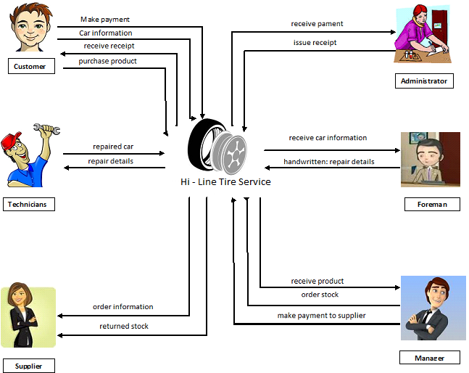Hi-line tire service should move to a computerized system. This will improve the way the business operates and save the business time and money. The new system will allow the business to move forward and keep accurate records of all their inventory and payments.

Figure ‑- Work Background

## **Method**

Hi-Line Tire Service current system makes use of Microsoft Word and Microsoft Excel as databases to store products and services data, customer data and sales data. Manual recording of the business data could have a negative effect on data accuracy and increase the risks of redundancy of data. Data necessary for generating reports are sometimes stored in files and this makes it difficult for the user to refer to files and data on the computer. The ideal solution would be that all data is available on an automated system, reducing the carbon footprint and allowing validation of data.

Stock is being done manually and it is difficult to keep track of current stock levels and maintain minimum stock levels.

They have many suppliers and their supplier information is saved on a file which can be lost.

Using a relational database will be good for backup purposes and will improve data processing. Security measures will be instilled through the use of passwords and different access levels for the different employees within the organizational structure.

Using set templates to complete orders and job cards will increase efficiency within the business as data used is directly linked to the database

## **Overview**

This developed system use on Hi-line Service Center. This includes Stores Management, Item management, Customer Management and Work Flow Management. These four Management System are combined through the server connection.

In this chapter the selected programming languages, application software packages, authoring and publishing tools that are used for the project are explained with reasons for their selection.

* Programming Language

The latest release of the Java Standard Edition is Java SE 8. With the advancement of Java and its widespread popularity, multiple configurations were built to suit various types of platforms. For example: J2EE for Enterprise Applications, J2ME for Mobile Applications.

The new J2 versions were renamed as Java SE, Java EE, and Java ME respectively. Java is guaranteed to be Write Once, Run Anywhere.

* Apache Struts Framework

Apache Struts is a free, open-source, MVC framework for creating elegant, modern Java web applications. It favors convention over configuration, is extensible using a plugin architecture, and ships with plugins to support REST, AJAX and JSON.

* Hibernate Framework

Hibernateis an object-relational mapping tool for the Java programming language. It provides a framework for mapping an object-oriented domain model to a relational database. Hibernate handles object-relational impedance mismatch problems by replacing direct, persistent database accesses with high-level object handling functions.

* NetBeans IDE

NetBeans IDE Fee, Open source quickly and easily develop desktop, mobile and web applications with Java, JavaScript, HTML5, PHP, C/C++ and more.

* MySQL Database

MySQL Open Source Relational Database Management System, Many of the world's largest and fastest-growing organizations including Facebook, Google, Adobe, Alcatel Lucent and Zappos rely on MySQL to save time and money powering their high-volume Web sites, business-critical systems and packaged software.

* jQuery UI

jQuery UI is a curated set of user interface interactions, effects, widgets, and themes built on top of the jQuery JavaScript Library. Whether you're building highly interactive web applications

# **Chapter 2 Background and Problem Statement**

Hi-Line Tire Service requested a system that improves the functionality of the business and the time consumption for daily operations, as well as to improve the security of business information. In order to see how the business could benefit from the development of our proposed system, an analysis which was focused on the business’ core functions was done.

## **Introduction**

During The analysis conducted identified many problems of which if they are solved it will increase their business revenue and productivity. The analysis revealed the following information about the business

Hi-Line Tire Service current system makes use of Microsoft Word and Microsoft Excel as databases to store products and services data, customer data and sales data. Manual recording of the business data could have a negative effect on data accuracy and increase the risks of redundancy of data. Data necessary for generating reports are sometimes stored in files and this makes it difficult for the user to refer to files and data on the computer. The ideal solution would be that all data is available on an automated system, reducing the carbon footprint and allowing validation of data.

Stock is being done manually and it is difficult to keep track of current stock levels and maintain minimum stock levels.

They have many suppliers and their supplier information is saved on a file which can be lost.

Using a relational database will be good for backup purposes and will improve data processing. Security measures will be instilled through the use of passwords and different access levels for the different employees within the organizational structure.

Using set templates to complete orders and job cards will increase efficiency within the business as data used is directly linked to the database

## **Literature Review**

Comparison of business and technical requirements for a commercial application package against the capabilities and features of a specific commercial application package for the purpose of defining the requirements that cannot be met.

Most businesses use this technique to determine what necessary steps they can take in order to move from its current state to its desired or future state the business want to reach.

Current System:

Hi-Line Tire Service is currently doing most of its business operation on a paper-based system. The business faces problems keeping track of the changes that can be done on the documents that they are using. The system that is in use makes it a bit hard for management to control and make strategic decision because sometimes the information might be wrong and inaccurate. By looking at the problems, it is clear that the current system doesn’t deal with all the problems and most of the business requirements are not fulfilled.

Table ‑ Current System Advantage and Disadvantage

|  |  |
| --- | --- |
| Advantages of the current system | Disadvantage of the current system |
| It has been in use since the business started, which is for a period since start date to up to date in use. | It is a paper-based system |
| It doesn’t require lot of support platform except a computer. | For it being a paper-based system, makes it to have limited functionality. |
| No additional cost | It requires lot of time. |
|  | Problem with Storage space. |

**Odoo ERP System**

Odoo ERP can be able to provide solutions to the business requirements and problems that the business is facing at the moment but does not user friendly to make Job Card, warehouse Management and also view other important things about the business. Other thing is Monthly they have to pay big amount for that system. Since this system is lacking a requirement to fulfill the business need

Table ‑ Odoo Advantages Disadvantage

|  |  |
| --- | --- |
| Advantages | Disadvantages |
| System generates multiple reports | Complicated and will require technical help |
| Has backup and restore utilities | Cost of purchasing the software |
| Searching facility |  |
| Effective security implemented | The company is not based in our country, the charges of buying the software will be high |

**Tire Inventory Solutions**

The new and used tire and wheel inventory is one of your most important business assets, but can be a handful to manage and control. Take your business to the next level with Tire Inventory Solutions. Now tire stores can easily manage their new and used tire and wheel stock. Advertise your complete tire inventory to wholesale and retail customers in minutes. With our easy-to-use online tire management software (htttp\\:www.tireinventorysolutions.com)

* Add dozens of tires to inventory at once.
* Easy management on computer or mobile device.
* Stock is posted to your Free website automatically.
* Display items on social media or any website in seconds.
* Free customer invoicing program included.
* Easy online ordering.

## **Problem Statement**

Tire Sales Management system will be a custom-built solution for the business that will fulfill all the business requirements as requested by the client. By the moment that this gap is filled, it will mean that the business will be more productive, and the employees will be able to work much more efficiently, and the work done will prove to hold better results and generate profit. This proposed system will have new features like web site.

Table ‑ TSM Advantages

|  |  |
| --- | --- |
| Advantages | Disadvantages |
| Low cost | It will require a period of 8 months to implement but it will be worth it. |
| Web sites will be developed | Will need technological help |
| User friendly with extensive search and help facilities |  |
| Security, Audit-Log, Backup and restore, Database and reports will be generated for business reasons. |  |

# **Chapter 3 Project Management**

**What is it?**

Although many of us (in our darker moments) take Dilbert’s view of “management,” it remains a very necessary activity when computer-based systems and products are built. Project management involves the planning, monitoring, and control of the people, process, and events that occur as software evolves from a preliminary concept to full operational deployment.

(A Practitioner’s Approach, 7th Edition, Roger S. Pressman, Chapter:24 Page**:**646)

**Who does it?**

Everyone “manages” to some extent, but the scope of management activities varies among people involved in a software project. A software engineer manages her day-to-day activities, planning, monitoring, and controlling technical tasks. Project managers plan, monitor, and control the work of a team of software engineers. Senior managers coordinate the interface between the business and software professionals.

(A Practitioner’s Approach, 7th Edition, Roger S. Pressman, Chapter:24 Page**:**646)

**Why is it important?**

Building computer software is a complex undertaking, particularly if it involves many people working over a relatively long time. That’s why software projects need to be managed.

(A Practitioner’s Approach, 7th Edition, Roger S. Pressman, Chapter:24 Page**:**646)

## **Approach**

The first getting it approved by the project supervisor. After getting approval, a project proposal was made defining the project scope. A functional document was made to be clear of this scope.

After requirement analysis, the technologies and languages to be used were carefully selected. The users of the system were declared with their relevant interactions with the system.

Then the designing started. Use case diagram, ERD diagram and class diagram were designed in this phase.

The implementation was done according to the design. As the final stage of development, system testing was done covering all the main functionalities of the system.

## **Initial Project Plan**

Following Gantt chart was made at the proposal stage of this project. The WBS and the time durations of the project tasks are clearly defined in the chart.

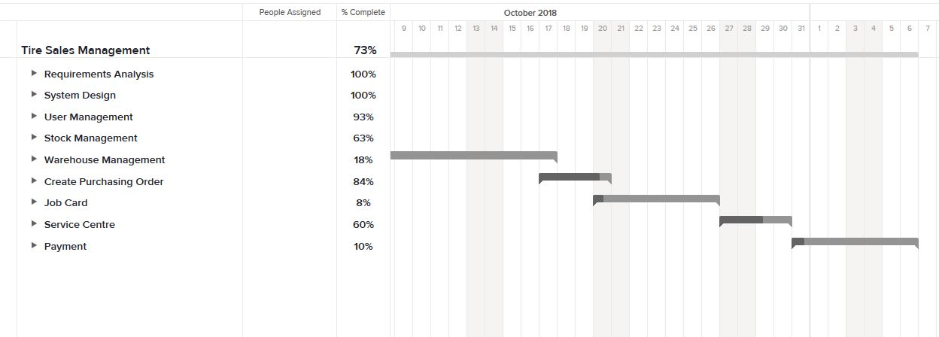

Figure ‑ -Gantt Chart

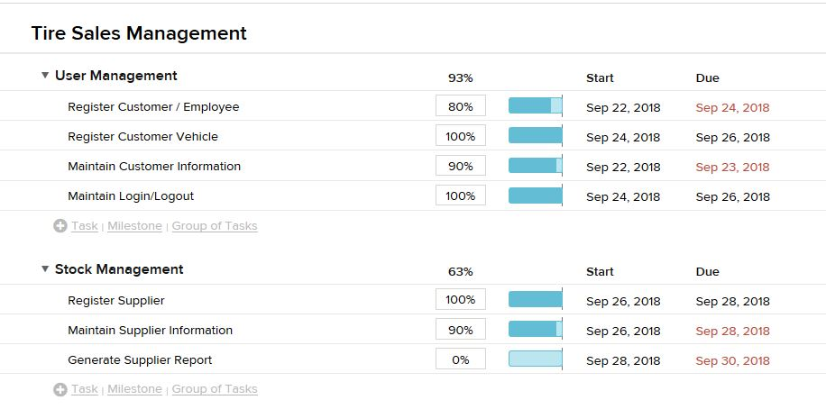

Figure ‑ - Work Breakdown 1

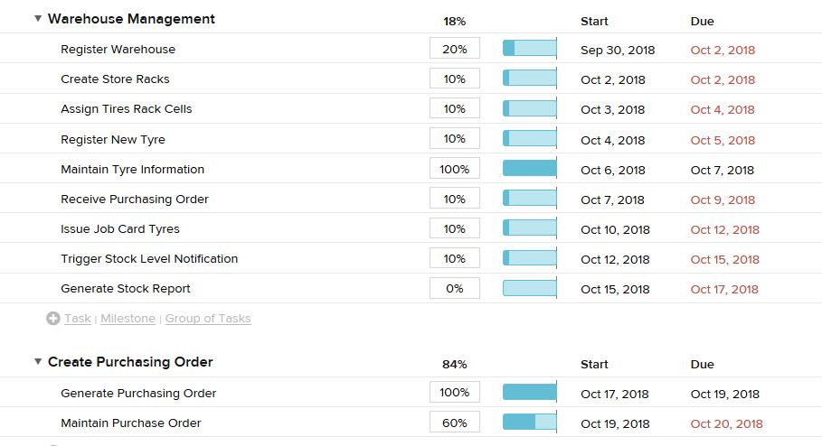

Figure ‑ Work Breakdown 2

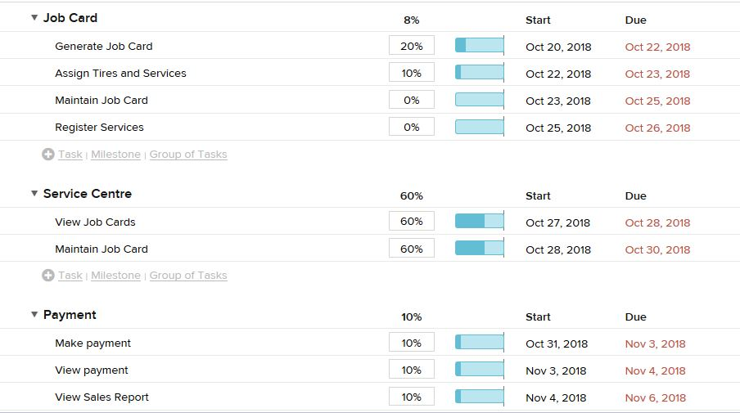

Figure ‑ Work Breakdown 3

## **Problems and Changes to the Plan**

reason for that was not being able to allocate sufficient time to this project. As an employed person, it was really challenging to allocate time for the academic work. As there were other course works related to other modules of this degree program, the main concentration was given to complete them to be submitted before the dead lines.

Because Lecture have Every weekend. Really hard to deal with time. Week days we have to done office works. After the office time we covered that time line however. So That’s the most difficult thing to faced.

# **Chapter 4 Feasibility Study**

What is a feasibility study? As the name implies, a feasibility study is used to determine the viability of an idea, such as ensuring a project is legally and technically feasible as well as economically justifiable. It tells us whether a project is worth the investment in some cases, a project may not be doable. There can be many reasons for this, including requiring too many resources, which not only prevents those resources from performing other tasks but also may cost more than an organization would earn back by taking on a project that isn’t profitable.

(Why a Feasibility Study is Important in Project Management :

https://www.simplilearn.com/feasibility-study-article)

## **Time Feasibility**

Current System No more time will be needed to implement the current system as it has been in use since the business started up and all the employees know how it works already.

This is Tire Sales Management (TSM) a specifically designed system to satisfy all of the business and functions. For that reason, it will take to design and implement the system in a few months. A project will fail if not completed on time. So, considering time feasibility before starting a project is essential.

## **Cost Feasibility.**

Current System no costs to develop the system since it is in use. But This TSM analysis is done by determining the economic benefits that are expected from a proposed system and comparing them with the cost. If benefits are higher than the cost, a decision can be taken as the project is economical vise feasible.

## **Scope Feasibility**

This specific and unique system will be designed to fit the business not like most systems that needs to be adapted to fit to each different kind of business processes. This will be designed to resolve all the problems that the business has as well making most of the business processes to be a lot quicker. This system will also take into consideration that will be using it, and will be user friendly. This system will be designed to make the most out of the resources that the business has and will increase productivity greatly.

Before going to start developing the system to the client, we had to meet the client to ensure that the system will have all the requirements from the client so this means that it should all their needs. it will be well designed to a high standard. It will lead to better performance and will better the job experience of each employee as it will enable them to focus more on their job and less on paper work which is time consuming, this proposed system will make everyone’s job/life easier and that should encourage the people to use it and to be enthusiastic about their training on the new system.

## **Technical Feasibility.**

Proposed system will have a few technology that can be a little more complex and expensive as additional hardware, such as well as a computer that can run Microsoft 7/8/10. And This System Developing to use NetBeans with Java Virtual Machine.

# **Chapter 5 Design**

What is it?

Design is what almost every engineer wants to do. It is the place where creativity rules where stakeholder requirements, business needs, and technical considerations all come together in the formulation of a product or system. Design creates a representation or model of the software, but unlike the requirements model (that focuses on describing required data, function, and behavior), the design model provides detail about software architecture, data structures, interfaces, and components that are necessary to implement the system.

Who does it?

Software engineers conduct each of the design tasks.

Why is it important?

Design allows you to model the system or product that is to be built. This model can be assessed for quality and improved before code is generated, tests are conducted, and end users become involved in large numbers. Design is the place where software quality is established.

(A Practitioner’s Approach, 7th Edition, Roger S. Pressman, Chapter:24 Page**:**646)

## **Introduction to the Proposed System**

Table ‑ Propose System

|  |  |  |
| --- | --- | --- |
| Requirement No. | Requirement Use Case | Description |
| 1. User Management | | |
| SUB – 101 | Register Customer / Employee | Customer/Employee provides details to the system and becomes registered. |
| SUB – 102 | Register Customer Vehicle | Store a Customer Vehicle Information |
| SUB – 103 | Maintain Customer Information | Customer/Employee information can be edited, deleted, read and updated |
| SUB – 104 | Maintain Customer History | Customer history record maintain |
| SUB – 105 | Maintain Login/Logout | The employee should be able to login and logout of the system. |
| 1. Stock Management | | |
| SUB – 201 | Register Suppler | Supplier provides details to the system and become registered. |
| SUB – 202 | Search Supplier Information | Supplier Information can be searched from the System |
| SUB – 203 | Maintain Supplier Information | Supplier Information can be edited, deleted, read and Update |
| SUB – 204 | Generate Supplier Report | Can be Download customer information MS Excel Format |
| 1. Create Purchasing Order | | |
| SUB – 301 | Generate Purchasing Order | Generate Purchasing Order |
| SUB – 302 | Maintain Purchase Order | Change Purchasing Order Status and Delete |
| 1. Warehouse Management | | |
| SUB – 401 | Register Warehouse | Provides warehouse information to the System |
| SUB – 402 | Create Store Racks | Provides information about Racks |
| SUB – 403 | Assign Tires Rack Cells | Adding New Tyres to the location racks |
| SUB – 404 | Register New Tyre | Provides Tyres Information to the System |
| SUB – 404 | Maintain Tyre Information | Tyre Information can be edited, deleted, read and Update |
| SUB – 405 | Receive Purchasing Order | Tyre Purchasing Order Received and change PO Status |
| SUB – 406 | Issue Job Card Tyres | Issue Tyres above Job Cards |
| SUB – 407 | Trigger Stock Level Notification | A Notification is sent to the system user if stock levels are low and new stock needs to be ordered. |
| SUB – 408 | Generate Stock Report | Can be Download Stock information MS Excel Format |
| 1. Job Card | | |
| SUB – 501 | Generate Job Card | Generating Job card to the Customer reference |
| SUB – 502 | Assign Tyres and Services | Assign Services and Tyres to the Generated Job card |
| SUB – 503 | Maintain Job Card | Change Status Above Job cards |
| SUB – 504 | Register Services | Provide details about Service information, Ex: wheel Balancing |
| 1. Service Centre | | |
| SUB – 601 | View Job Cards | View the Job Card Queue, and getting Tyres in warehouse |
| SUB – 602 | Maintain Job Card | Job Card Status Change |
| 1. Payment | | |
| SUB – 701 | Make payment | Make payment to Purchasing Order and getting Job Card Payment |
| SUB – 702 | View payment | View payment History |
| SUB – 703 | View Sales Report | Generate Daily, and Weekly or given date range Sales report and Download MS Excel Format |

User Management

Table ‑ User Management

|  |  |
| --- | --- |
| **Requirement** | **Explanation** |
| Requirement No. | SUB – 101 |
| Requirement Title | Register Customer / Employee |
| Requirement Text | Customer must provide office administrator with all details that are required. The customer information will then be updated onto the database. |
| Requirement Type | Functional |
| Requirement details and constraints | Customer must provide correct information. A customer number will be generated and saved on the database. |
| Revision date and Revision Number | Version 1.0 |
| Criticality/Priority | Vital |
| User Acceptance Criteria | The System must be able to register customer and store their details in the system. The following information must be stored: First Name, Last Name , Telephone Number, Address |

Table ‑ Register Customer Vehicle

|  |  |
| --- | --- |
| **Requirement** | **Explanation** |
| Requirement No. | SUB – 102 |
| Requirement Title | Register Customer Vehicle |
| Requirement Text | Customer must provide Vehicle details office administrator with all details that are required. The Vehicle information will then be updated onto the database. |
| Requirement Type | Functional |
| Requirement details and constraints | Customer must provide correct Vehicle information. |
| Revision date and Revision Number | Version 1.0 |
| Criticality/Priority | Vital |
| User Acceptance Criteria | The System must be able to register Vehicle and store their details in the system. The following information must be stored: Vehicle Brand, Vehicle Registered Number , |

Table ‑ Customer Information

|  |  |  |
| --- | --- | --- |
| **Requirement** | **Explanation** | |
| Requirement No. | SUB – 103 | |
| Requirement Title | Maintain Customer Information | |
| Requirement Text | Office administrator must be able to edit, update, read and delete customer information. | |
| Requirement Type | Functional | |
| Requirement details and constraints | Customer information will automatically be saved if any changes occur | |
| Revision date and Revision Number | Version 1.0 | |
| Criticality/Priority | Vital | |
| User Acceptance Criteria | The System must be able to update and store customers information should any basic information change. | |
|  |  | |
| **Requirement** | | **Explanation** | |
| Requirement No. | | SUB – 104 | |
| Requirement Title | | Maintain Customer History | |
| Requirement Text | | Office administrator must be able see customer history recorde | |
| Requirement Type | | Functional | |
| Requirement details and constraints | | Customer information will automatically be saved if any changes occur | |
| Revision date and Revision Number | | Version 1.0 | |
| Criticality/Priority | | Vital | |
| User Acceptance Criteria | | The System must be able to find about customer details | |

Table ‑ Maintain Login/Logout

|  |  |
| --- | --- |
| **Requirement** | **Explanation** |
| Requirement No. | SUB – 105 |
| Requirement Title | Maintain Login/Logout |
| Requirement Text | A user logins to the system for increased functionality and authorisation to use the system and logs out for security purposes. |
| Requirement Type | Functional |
| Requirement details and constraints | * A user must have a unique username and a strong password to login to the system * The user must logout when they are done using the System |
| Revision date and Revision Number | Version 1.0 |
| Criticality/Priority | Vital |
| User Acceptance Criteria | The System must be able to validate user login detail and give them correct access levels to the system |

Stock Management

Table ‑ Stock Management

|  |  |
| --- | --- |
| **Requirement** | **Explanation** |
| Requirement No. | SUB – 201 |
| Requirement Title | Register Suppler |
| Requirement Text | Supplier must provide office administrator with all details that are required. The Supplier information will then be updated onto the database. |
| Requirement Type | Functional |
| Requirement details and constraints | Customer must provide correct information. A customer number will be generated and saved on the database. |
| Revision date and Revision Number | Version 1.0 |
| Criticality/Priority | Vital |
| User Acceptance Criteria | The System must be able to register customer and store their details in the system. The following information must be stored: Supplier Name, Last Name , Telephone Number, Address |

Table ‑ Search Supplier

|  |  |
| --- | --- |
| **Requirement** | **Explanation** |
| Requirement No. | SUB – 202 |
| Requirement Title | Search Supplier Information |
| Requirement Text | Clerk must be able to search for any supplier by either using their Company name, address or Contact number. All details about the supplier must be displayed. |
| Requirement Type | Functional |
| Requirement details and constraints | Supplier must already be registered |
| Revision date and Revision Number | Version 1.0 |
| Criticality/Priority | Vital |
| User Acceptance Criteria | The system must be able to search for stored supplier information by Supplier Name. |
| **Requirement** | **Explanation** |
| Requirement No. | SUB – 203 |
| Requirement Title | Maintain Supplier Information |
| Requirement Text | Office administrator must be able to edit, update, read and delete supplier information. Once changed here it will automatically update in the database. |
| Requirement Type | Functional |
| Requirement details and constraints | Supplier must be registered |
| Revision date and Revision Number | Version 1.0 |
| Criticality/Priority | Vital |
| User Acceptance Criteria | The System must be able to update and store supplier information to ensure that the most up to date version of information is available. |

Table ‑ Generate Supplier Report

|  |  |
| --- | --- |
| **Requirement** | **Explanation** |
| Requirement No. | SUB – 204 |
| Requirement Title | Generate Supplier Report |
| Requirement Text | This report contains all the information about each Supplier. |
| Requirement Type | Functional |
| Requirement details and constraints | Manager must request report. Report must be able to be generated on request. |
| Revision date and Revision Number | Version 1.0 |
| Criticality/Priority | Vital |
| User Acceptance Criteria | The System must be able to generate a report detailing the information of the Supplier |

Create Purchasing Order

Table ‑ Generate Purchasing Order

|  |  |
| --- | --- |
| **Requirement** | **Explanation** |
| Requirement No. | SUB – 301 |
| Requirement Title | Generate Purchasing Order |
| Requirement Text | Stock Item Purchasing Order can be create on the System |
| Requirement Type | Functional |
| Requirement details and constraints | Must order items that stocks or is capable of getting into the store |
| Revision date and Revision Number | Version 1.0 |
| Criticality/Priority | Vital |
| User Acceptance Criteria | The system must be able to generate a purchase order for each purchase. This purchase order must show the Supplier Information, Items Ordered with Prices and Total Amount Owed per Purchase Order. |

Table ‑ Maintain Purchase Order

|  |  |
| --- | --- |
| **Requirement** | **Explanation** |
| Requirement No. | SUB – 302 |
| Requirement Title | Maintain Purchase Order |
| Requirement Text | This report contains all the information about each Supplier. |
| Requirement Type | Functional |
| Requirement details and constraints | The salesperson must be able to find any given purchase order and edit, update, read and delete it. Once changed here it will automatically update in the database. |
| Revision date and Revision Number | Version 1.0 |
| Criticality/Priority | Vital |
| User Acceptance Criteria | The System must be able to update or remove the purchase order |

Warehouse Management

Table ‑ Warehouse Management

|  |  |
| --- | --- |
| **Requirement** | **Explanation** |
| Requirement No. | SUB – 401 |
| Requirement Title | Register Warehouse |
| Requirement Text | Provide Valid Name for the Warehouse location |
| Requirement Type | Functional |
| Requirement details and constraints | Must be able to find unique name for warehouse |
| Revision date and Revision Number | Version 1.0 |
| Criticality/Priority | Vital |
| User Acceptance Criteria | The System must be able to register Warehouse Location name |

Table ‑ Create Store Racks

|  |  |
| --- | --- |
| **Requirement** | **Explanation** |
| Requirement No. | SUB – 402 |
| Requirement Title | Create Store Racks |
| Requirement Text | Provide Valid Name for the Racks |
| Requirement Type | Functional |
| Requirement details and constraints | Must be able to find uniquely name Racks |
| Revision date and Revision Number | Version 1.0 |
| Criticality/Priority | Vital |
| User Acceptance Criteria | The System must be able to register Rack |

Table ‑ Assign Tire Racks Cells

|  |  |
| --- | --- |
| **Requirement** | **Explanation** |
| Requirement No. | SUB – 403 |
| Requirement Title | Assign Tires Rack Cells |
| Requirement Text | When a new stock item is received Item can be assign to that Rack cells |
| Requirement Type | Functional |
| Requirement details and constraints | The new stock will have a that Cell code |
| Revision date and Revision Number | Version 1.0 |
| Criticality/Priority | Vital |
| User Acceptance Criteria | The system must be able to record and store information |

Table ‑ Register New Item

|  |  |
| --- | --- |
| **Requirement** | **Explanation** |
| Requirement No. | SUB – 404 |
| Requirement Title | Register New Tyre |
| Requirement Text | When a new item is received it needs to be entered into the database. |
| Requirement Type | Functional |
| Requirement details and constraints | The new Item will have a unique Name. |
| Revision date and Revision Number | Version 1.0 |
| Criticality/Priority | Vital |
| User Acceptance Criteria | The system must be able to record and store information on a new item which will be received. The following information needs to be stored: Brand, Category, Item Name |

Table ‑ Maintain Tyre Information

|  |  |
| --- | --- |
| **Requirement** | **Explanation** |
| Requirement No. | SUB – 405 |
| Requirement Title | Maintain Tyre Information |
| Requirement Text | Information about Tyre can be edited, updated, read and deleted here. Any changes will be automatically updated in the database. |
| Requirement Type | Functional |
| Requirement details and constraints | Attributes about Tyres can change. It needs to remain up to date with the current in store. |
| Revision date and Revision Number | Version 1.0 |
| Criticality/Priority | Vital |
| User Acceptance Criteria | The System must be able to update and store Tyres information to ensure that the most up to date version of information is available. |

Table ‑ Receive Purchasing Order

|  |  |
| --- | --- |
| **Requirement** | **Explanation** |
| Requirement No. | SUB – 406 |
| Requirement Title | Receive Purchasing Order |
| Requirement Text | When a new stock Tyres is received it needs to be entered into the database. |
| Requirement Type | Functional |
| Requirement details and constraints | The new stock will store in a Rack cell, needs to be given to it that corresponds to its rack serial |
| Revision date and Revision Number | Version 1.0 |
| Criticality/Priority | Vital |
| User Acceptance Criteria | The system must be able to record and store information on a new stock item which will be received and sold. |

Table ‑ Job Card

|  |  |
| --- | --- |
| **Requirement** | **Explanation** |
| Requirement No. | SUB – 407 |
| Requirement Title | Issue Job Card Tyres |
| Requirement Text | Once the services request is submitted a job number should automatically be generated. |
| Requirement Type | Functional |
| Requirement details and constraints | The required details has to be entered and the car should be validated |
| Revision date and Revision Number | Version 1.0 |
| Criticality/Priority | Vital |
| User Acceptance Criteria | All required field on the repair request should be validated |

Table ‑ Stock Level Notification

|  |  |
| --- | --- |
| **Requirement** | **Explanation** |
| Requirement No. | SUB – 408 |
| Requirement Title | Trigger Stock Level Notification |
| Requirement Text | The system should be able to notify or alert the office administrator if the amount of stock level is low |
| Requirement Type | Functional |
| Requirement details and constraints | When the amount of declared low level is reached , it should notify the office administrator |
| Revision date and Revision Number | Version 1.0 |
| Criticality/Priority | Vital |
| User Acceptance Criteria | The System should warn the office administrator when the stock level reaches a specific point |

Table ‑ Stock Report

|  |  |
| --- | --- |
| **Requirement** | **Explanation** |
| Requirement No. | SUB – 409 |
| Requirement Title | Generate Stock Report |
| Requirement Text | This report contains all the information about the level of stock in store. The status of stock also needs to be shown with regards to where the stock is. |
| Requirement Type | Functional |
| Requirement details and constraints | Manager must request report. Report must be able to be generated on request. |
| Revision date and Revision Number | Version 1.0 |
| Criticality/Priority | Vital |
| User Acceptance Criteria | The System must be able to generate a report detailing the current stock levels of all stock currently within inventory. |

Job Card

Table ‑ Job Card Generate

|  |  |  |  |
| --- | --- | --- | --- |
| **Requirement** | | **Explanation** | |
| Requirement No. | | SUB – 501 | |
| Requirement Title | | Generate Job Card | |
| Requirement Text | | Once the repair request is submitted a job number should automatically be generated. | |
| Requirement Type | | Functional | |
| Requirement details and constraints | | The required details has to be entered and the car should be validated | |
| Revision date and Revision Number | | Version 1.0 | |
| Criticality/Priority | | Vital | |
| User Acceptance Criteria | | All required field on the repair request should be validated | |
| **Requirement** | **Explanation** | |
| Requirement No. | SUB – 502 | |
| Requirement Title | Assign Tyres and Services | |
| Requirement Text | The system should be able to assign the repair request for the specific car to the Item and Services | |
| Requirement Type | Functional | |
| Requirement details and constraints | The car should be registered on the system and active | |
| Revision date and Revision Number | Version 1.0 | |
| Criticality/Priority | Vital | |
| User Acceptance Criteria | The system should be able to save the job card services and Items | |

Table ‑ Maintain Job Card

|  |  |  |  |
| --- | --- | --- | --- |
| **Requirement** | | **Explanation** | |
| Requirement No. | | SUB – 503 | |
| Requirement Title | | Maintain Job Card | |
| Requirement Text | | Mechanic updates the system that the car is either successfully repaired. This means the car is ready for collection. | |
| Requirement Type | | Functional | |
| Requirement details and constraints | | Mechanic has finished working with a specific car. The car is now in storage and a show the status to the customer that repair is complete. | |
| Revision date and Revision Number | | Version 1.0 | |
| Criticality/Priority | | Vital | |
| User Acceptance Criteria | | The System must be able to update the status of a repair which has been logged into the system. This will be used to track the status of the repair through to complete as well as provide details to the repair such as “awaiting parts”. | |
| **Requirement** | **Explanation** | |
| Requirement No. | SUB – 504 | |
| Requirement Title | Register Services | |
| Requirement Text | New Service needs to be registered is registered by a office admin. | |
| Requirement Type | Functional | |
| Requirement details and constraints | Service will be registered and will have unique code. | |
| Revision date and Revision Number | Version 1.0 | |
| Criticality/Priority | Vital | |
| User Acceptance Criteria | The system must be able to store at least the following | |

Service Centre

Table ‑ Maintain Job Card

|  |  |  |  |
| --- | --- | --- | --- |
| **Requirement** | | **Explanation** | |
| Requirement No. | | SUB – 601 | |
| Requirement Title | | View Job Cards | |
| Requirement Text | | Show the job card list and service information queue | |
| Requirement Type | | Functional | |
| Requirement details and constraints | | The required details has to be entered and the car should be validated | |
| Revision date and Revision Number | | Version 1.0 | |
| Criticality/Priority | | Vital | |
| User Acceptance Criteria | | All required field on the service, Item request should be validated | |
| **Requirement** | **Explanation** | |
| Requirement No. | SUB – 602 | |
| Requirement Title | Maintain Job Card | |
| Requirement Text | Must be able to change job card status and information. | |
| Requirement Type | Functional | |
| Requirement details and constraints | The required details has to be entered and the car should be validated | |
| Revision date and Revision Number | Version 1.0 | |
| Criticality/Priority | Vital | |
| User Acceptance Criteria | All required field on the service, Item request should be validated | |

Payment

|  |  |
| --- | --- |
| **Requirement** | **Explanation** |
| Requirement No. | SUB – 701 |
| Requirement Title | Make payment |
| Requirement Text | The system should be able to allow the office administrator to save a payment and its details when a Job finish.  The manager is responsible to pay suppliers. |
| Requirement Type | Functional |
| Requirement details and constraints | When a payment is made the status of the supplier should be updated to “paid” |
| Revision date and Revision Number | Version 1.0 |
| Criticality/Priority | Vital |
| User Acceptance Criteria | The system must be able to save the payment and its details |

Table ‑ View Payment

|  |  |
| --- | --- |
| **Requirement** | **Explanation** |
| Requirement No. | SUB – 702 |
| Requirement Title | View payment |
| Requirement Text | This function should be able to view the previous payments |
| Requirement Type | Functional |
| Requirement details and constraints | An payment must exist before it can be viewed |
| Revision date and Revision Number | Version 1.0 |
| Criticality/Priority | Vital |
| User Acceptance Criteria | The system must display previous payments |

Table ‑ View Sales Report

|  |  |
| --- | --- |
| **Requirement** | **Explanation** |
| Requirement No. | SUB – 703 |
| Requirement Title | View Sales Report |
| Requirement Text | View Sales report given time period with received and given payments |
| Requirement Type | Functional |
| Requirement details and constraints | Manager must request report. Report must be able to be generated on request. |
| Revision date and Revision Number | Version 1.0 |
| Criticality/Priority | Vital |
| User Acceptance Criteria | The System must be able to generate a report detailing sales of rims to its customers. The report should allow the user to specify the time period which they wish to view. |

Table ‑ View Sales Report

**Use Case Diagram**

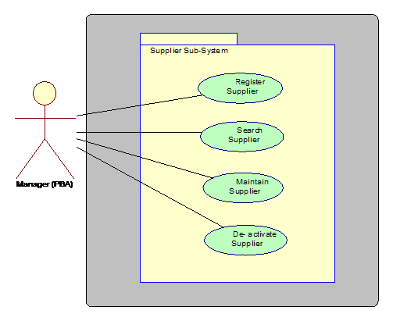**Supplier**

Figure ‑ Supplier Use Case

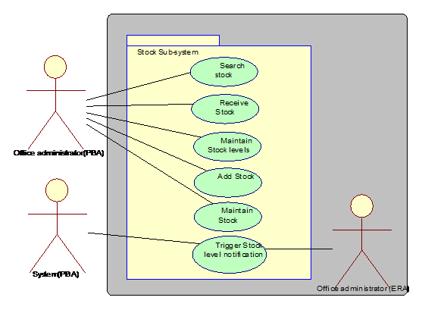**Stock Sub-System**

Figure ‑ Stock Use Case

**Report**

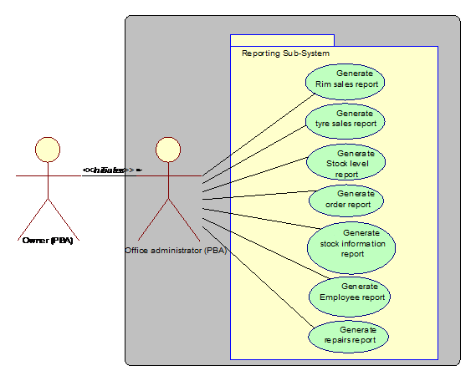

Figure ‑ Report Use Case

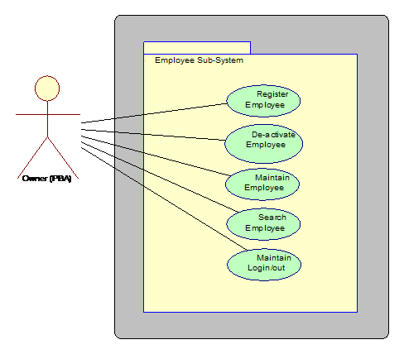**Employees**

Figure ‑ Employee Use Case

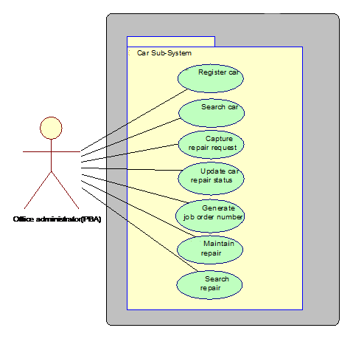**Cars**

Figure ‑ Car Use Case

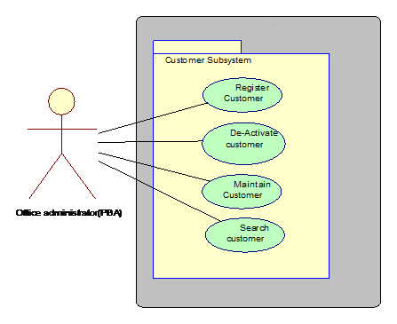**Customer**

Figure ‑ Customer Use Case

**Payments**

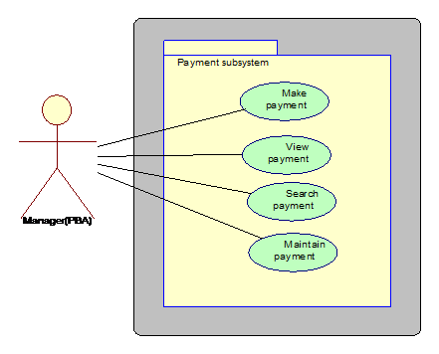

Figure ‑ Payment Use Case

**Sales**

Figure ‑ Sales Use Case

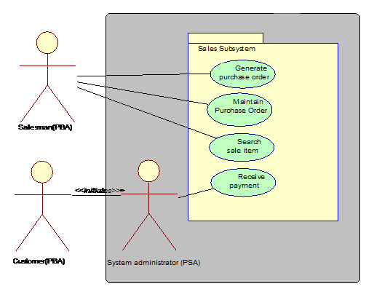

Entity Relationship Diagram

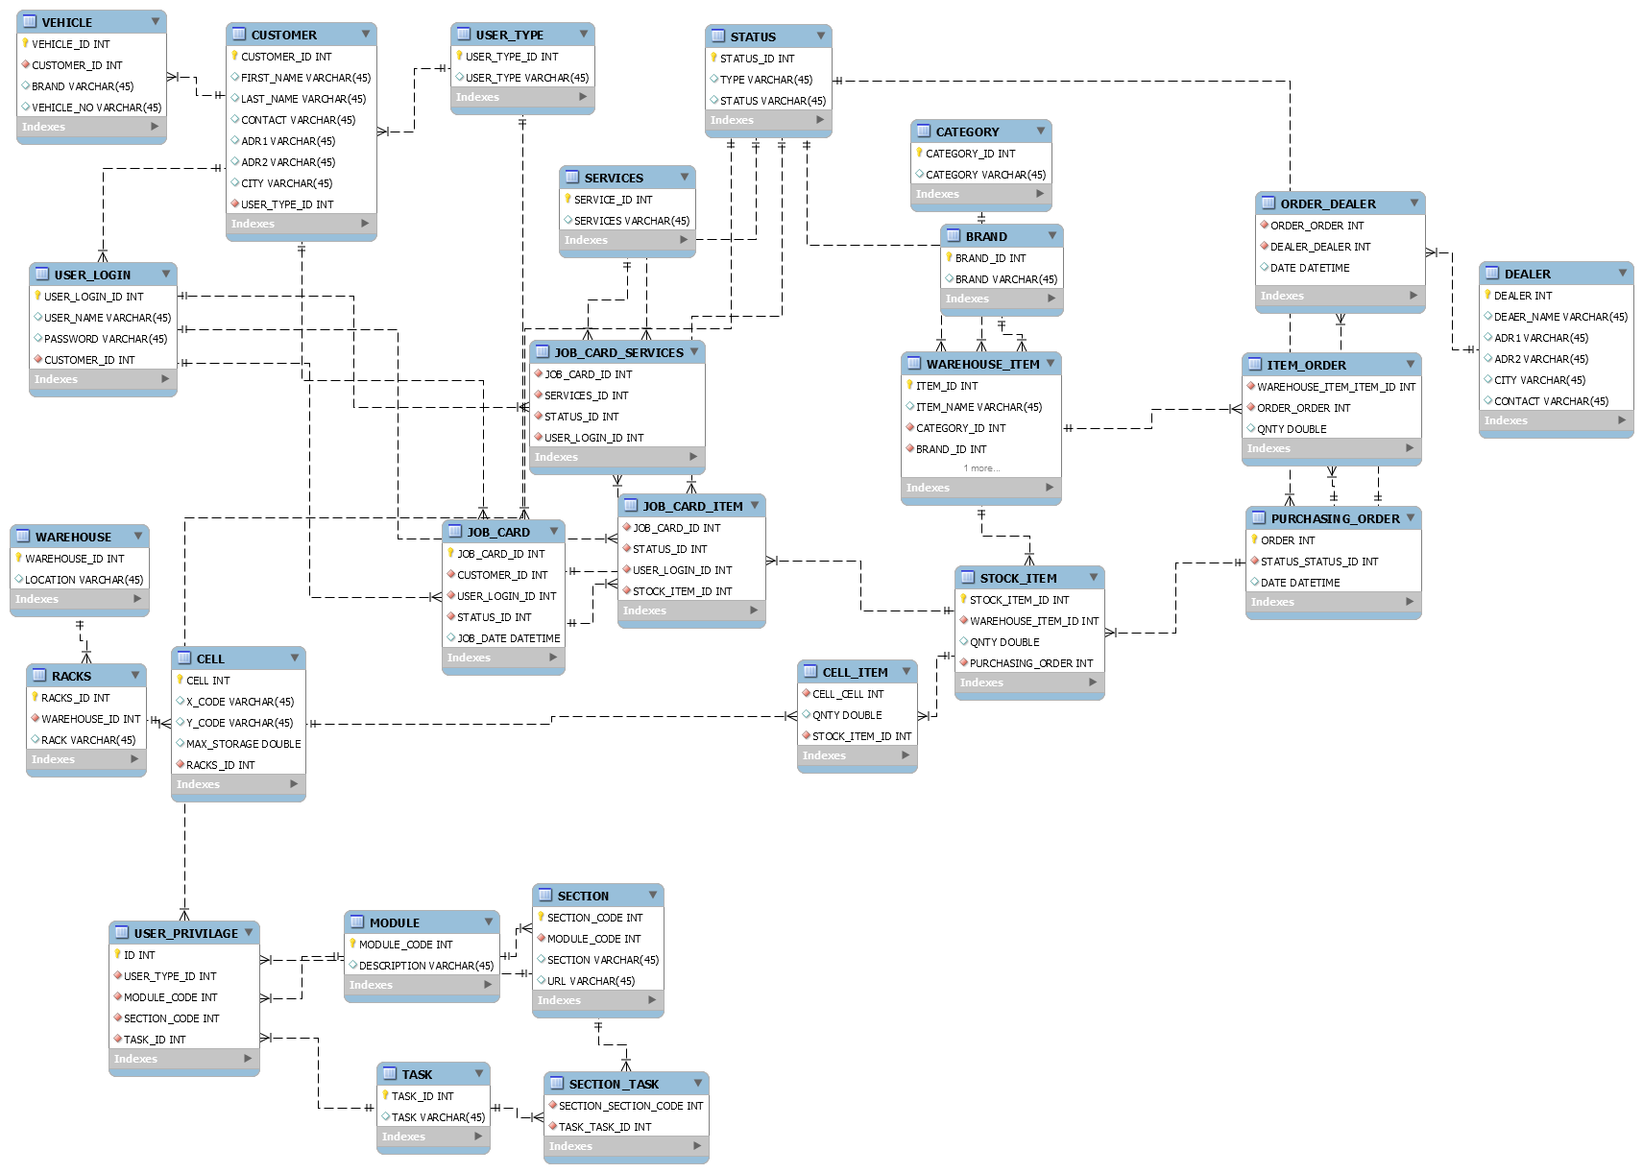

Figure ‑ ERD Diagram

## **Hardware and software requirements**

Hardware Requirements

* Apply Dedicate Server
  + RAM-Minimum 8GB
  + Hard Disk-Minimum 500GB free space
  + Processor-Intel Core i3 or above
* Publish in cyberspace
* Purchase Dedicated Domain

Software Requirements

* Apply Dedicate Server
* Operating System-:Linux Server OS
* MySql Server DB Management System
* Java Virtual Machine
* Glassfish Server
* publish this site in Cyberspace
* chrome browser

## **Evaluating of Solutions**

# **Chapter 6 implementation**

Once the requirement and designing are done, the next phase which comes according to the SDLC is the cording or the construction part. If the above design is completed carefully according to the gathered requirement, cording is quiet strait forward. Coding or implementation can be carried out under many way, but using the best practices and approaches will only render quick and effective results. Therefore, forming up a proper implementation plan before starting off actual coding is immensely important for an implementation process to become a success.

## Java Validation Regex

public static boolean validateString(String text) throws Exception {

return text.matches("^[\\p{L} .'-]+$");

}

public static boolean validateVF0(String text) throws Exception {

return text.matches("^[a-zA-Z0-9\\s_-]+$");

}

public static boolean validateNAME(String text) throws Exception {

return text.matches("^[a-zA-Z0-9 ]+$") && text.length() <= 50;

}

public static boolean validateNUMBER(String numericString) throws Exception {

return numericString.matches("^[0-9]*$");

}

public static boolean validateEMAIL(String email) throws Exception {

return email.matches("^[_A-Za-z0-9-]+(\\.[_A-Za-z0-9-]+)*@[A-Za-z0-9]+(\\.[A-Za-z0-9]+)*(\\.[A-Za-z]{2,})$") && email.length() <= 50;

}

public static boolean validatePHONENO(String numericString) throws Exception {

return numericString.matches("^[0-9]*$") && numericString.length() <= 15;

}

public static boolean validateNIC(String nic) {

return nic.matches("^[0-9]+[VX]?$") && nic.length() == 10;

}

public static boolean validateSPECIALCHAR(String specialChars) throws Exception {

return specialChars.matches("[~@#$&!~]+");

}

public static boolean validateDESCRIPTION(String text) {

return text.matches("^(.*/)?(?:$|(.+?)(?:(\\.[^.]*$)|$))") && text.length() <= 150;

}

public static boolean validateHEXA(String text) {

return text.matches("[\\dA-Fa-f]+");

}

public static boolean validateURL(String text) {

return text.matches("\\b(https?|ftp|file|ldap)://"

+ "[-A-Za-z0-9+&@#/%?=~_|!:,.;]"

+ "*[-A-Za-z0-9+&@#/%=~_|]") && text.length() <= 150;

}

## MD5 Password Encrypted

public static String generateHash(String password) throws Exception {

MessageDigest md = MessageDigest.getInstance("MD5");

byte[] messageDigest = md.digest(password.getBytes());

BigInteger number = new BigInteger(1, messageDigest);

String hashtext = number.toString(16);

return hashtext;

}

## Mysql Hibernate Database Configuration (Set System Environment variable as : HiLine )

Environment Variable that Path : C:\HiLine\sconfig\config.xml

<config>

<!-- Database configuration -->

<dbpoolmax>30</dbpoolmax>

<dbpoolmin>10</dbpoolmin>

<dbpoolmaxcon>50</dbpoolmaxcon>

<dbpoolcontimeout>5000</dbpoolcontimeout> <!-- ms -->

<dbpoolconexpirtimeout>0</dbpoolconexpirtimeout> <!-- s -->

<dbpoolurl>jdbc:mysql://localhost:3306/warehouse</dbpoolurl>

<dbpoolusername>root</dbpoolusername>

<dbpoolpassword>3331333233333334</dbpoolpassword>

<dbpooldriver>com.mysql.jdbc.Driver</dbpooldriver>

<dbdialect>org.hibernate.dialect.MySQLDialect</dbdialect>

<dbpooltype>2</dbpooltype>

</config>

## ContextListner Class

public class ContextListener implements ServletContextListener {

@Override

public void contextInitialized(ServletContextEvent sce) {

try {

if (System.getenv(Configurations.ENV_VARIABLE_CONFIG) != null) {

//intialize hibernate

Configurations.PATH_ROOT = System.getenv(Configurations.ENV_VARIABLE_CONFIG);

HibernateUtil hibernateInit = new HibernateUtil();

hibernateInit.initialize();

} else {

System.out.println(SystemMessage.INITIAL_ERROR);

System.exit(0);

}

} catch (Exception e) {

e.printStackTrace();

}

}

@Override

public void contextDestroyed(ServletContextEvent sce) {

try {

System.out.println("Global Variable Destroyed.");

} catch (Exception e) {

e.printStackTrace();

}

}

}

## Access Checking Method

public boolean checkAccess(String method, int userRole) {

boolean status;

applyUserPrivileges();

String page = PageVarList.Register_Agent;

inputBean.setPageCode(page);

String task = null;

if ("list".equals(method)) {

task = TaskVarList.VIEW;

} else if ("delete".equals(method)) {

task = TaskVarList.DELETE;

} else if ("find".equals(method)) {

task = TaskVarList.VIEW;

} else if ("update".equals(method)) {

task = TaskVarList.UPDATE;

} else if ("add".equals(method)) {

task = TaskVarList.ADD;

} else if ("export".equals(method)) {

task = TaskVarList.DOWNLOAD;

}

if ("execute".equals(method)) {

status = true;

} else {

HttpSession session = ServletActionContext.getRequest().getSession(false);

status = new Common().checkMethodAccess(task, Integer.parseInt(page), session);

}

return status;

}

private boolean applyUserPrivileges() {

HttpServletRequest request = ServletActionContext.getRequest();

List<TaskBean> tasklist = new Common().getUserTaskListByPage(PageVarList.Register_Agent, request);

inputBean.setAdd(true);

inputBean.setDelete(true);

inputBean.setView(true);

inputBean.setUpdate(true);

if (tasklist != null && tasklist.size() > 0) {

for (TaskBean task : tasklist) {

if (task.getTASK_ID().equalsIgnoreCase(TaskVarList.ADD)) {

inputBean.setAdd(false);

} else if (task.getTASK_ID().equalsIgnoreCase(TaskVarList.UPDATE)) {

inputBean.setUpdate(false);

} else if (task.getTASK_ID().equalsIgnoreCase(TaskVarList.DELETE)) {

inputBean.setDelete(false);

} else if (task.getTASK_ID().equalsIgnoreCase(TaskVarList.VIEW)) {

inputBean.setView(false);

}

}

}

return true;

}

# **Chapter 7**

# **Testing and Verification**

Software is tested to uncover errors that were made inadvertently as it was designed and constructed. But how conduct the tests? Should develop a formal plan tests? Should test the entire program as a whole or run tests only on a small part of it? Should rerun tests already conducted as add new components to a large system? When should involve the customer? These and many other questions are answered when develop a software testing strategy.

**Testing Methodologies**

Unit Testing

Unit testingfocuses verification effort on the smallest unit of software design the software Component or module. Using the component-level design description as a guide, important control paths are tested to uncover errors within the boundary of the module. The relative complexity of tests and the errors those tests uncover is limited by the constrained scope established for unit testing. The unit test focuses on the internal processing logic and data structures within the boundaries of a component. This type of testing can be conducted in parallel for multiple components.

Integration Testing

Integration testing is a systematic technique for constructing the software architecture while at the same time conducting tests to uncover errors associated with interfacing. The objective is to take unit-tested components and build a program structure that has been dictated by design.

Alpha and Beta Testing

It is virtually impossible for a software developer to foresee how the customer will really use a program. Instructions for use may be misinterpreted; strange combinations of data may be regularly used; output that seemed clear to the tester may be unintelligible to a user in the field.

Test Plan

Table ‑ Test Plan

|  |  |  |  |  |  |
| --- | --- | --- | --- | --- | --- |
| **Test ID** | **Test Name** | **Description** | **Prerequisites** | **Test Steps** | **No of Test Cases** |
| 1 | Admin Registration | To verify that new admins can be registered | **-** | Enter Admin details and click register button | 4 |
| 2 | Admin Login | To verify that login name and password are correct and they belong to an admin | An admin should be registered before trying to Login | Enter the Login name and password and click Login button | 2 |
| 3 | Casher/Office Employee Registration | To verify that register Office Employee are correct | An Casher/Office Employee should be registered before trying to Login | Enter User details and click register button | 4 |
| 4 | TSM Login | To verify that login name and password are correct and they belong to a Tire Sale Management | Tire Sale Management should be registered before trying to Login | Enter the Login name and password and click Login button | 2 |
| 5 | Customer/Vehicle  Registration | To verify that new Customers can be registered | - | Enter Customer/Vehicle details and click register button | 4 |
| 6 | Item Register | To verify that New Item Details Enter Correctly to the Add New Item | Valid information | Enter the Item Details and click Save button | 4 |
| 7 | Warehouse registration | Enter valid details  About warehouse | Valid name | After Details Save button click | 2 |
| 8 | Warehouse Rack Register | Enter Information about Racks | Valid information Racks Name, Sizes | Save the Racks in system | 4 |
| 9 | Create Purchasing Order | Enter Valid Items and Valid Agent Details | EnterInformation should be valid | Create PO click and create PO | 8 |
| 10 | User Privilege | Select User and set User Privilege | Can Create new user or user can set new privilege | Login with a kind of user and check privilege and access | 2 |
| 11 | Get the PO Report | Select date range report getting | Should be generate Excel format Report | Select Date Range and Click Export then Generate Excel Report | 4 |
| 12 | Delete PO Item | View PO and delete PO Item | Open PO Order and can delete about list Item | Open PO, Select Item and press delete | 2 |
| 13 | Update User Details | Edit button press and load User Details | Can edit user Information and update | Enter Update Details press Update button | 2 |
| 14 | Update Item Details | Update Item List Item Details | Can Update Item data | Edit Item Details and press update Button | 2 |
| 15 | Agent Can register TSM System | Agent Details filling | Valid Agent Details | Enter details and click Save button | 2 |
| 16 | Update Agent Details | Update Agent details edit when click press the edit button | Enter Valid update information | Then click update button should update details | 2 |

Table ‑ Blackbox Testing (Login)

|  |  |  |  |  |  |
| --- | --- | --- | --- | --- | --- |
| Project name – Tire Sales Management System | | | | | |
| Test Type=: Black Box Testing | | | | | |
| Step | Test Step | Expected Result | Actual Result | Status Passed/Fail |  |
| 01 | Customer Login | Redirect to Customer Home | Redirect to Customer Home | passed |
| Screenshot | | | | |  |

Table ‑ Blackbox Testing (Customer Register)

|  |  |  |  |  |  |
| --- | --- | --- | --- | --- | --- |
| Project name – Tire Sales Management System | | | | | |
| Test Type=: Black Box Testing | | | | | |
| Step | Test Step | Expected Result | Actual Result | Status Passed/Fail |  |
| 02 | Register Customer | Register Success Message Showing | Register Success Message Showing | passed |
| Screenshot | | | | |  |

Table ‑ Blackbox Testing (Customer Update)

|  |  |  |  |  |  |
| --- | --- | --- | --- | --- | --- |
| Project name – Tire Sales Management System | | | | | |
| Test Type=: Black Box Testing | | | | | |
| Step | Test Step | Expected Result | Actual Result | Status Passed/Fail |  |
| 03 | Update Customer | Update Success Message Showing | Update Success Message Showing | passed |
| Screenshot | | | | |  |
| Project name – Tire Sales Management System | | | | | |
| Test Type=: Black Box Testing | | | | | |
| Step | Test Step | Expected Result | Actual Result | Status Passed/Fail |  |
| 04 | Register Warehouse Item | Register Success Message Showing | Register Success Message Showing | passed |
| Screenshot | | | | |  |

Table ‑ Blackbox Testing (Update Item)

|  |  |  |  |  |  |
| --- | --- | --- | --- | --- | --- |
| Project name – Tire Sales Management System | | | | | |
| Test Type=: Black Box Testing | | | | | |
| Step | Test Step | Expected Result | Actual Result | Status Passed/Fail |  |
| 05 | Update Item | Update Success Message Showing | Update Success Message Showing | passed |
| Screenshot | | | | |  |

Table ‑ Blackbox Testing (Item Delete)

|  |  |  |  |  |  |
| --- | --- | --- | --- | --- | --- |
| Project name – Tire Sales Management System | | | | | |
| Test Type=: Black Box Testing | | | | | |
| Step | Test Step | Expected Result | Actual Result | Status Passed/Fail |  |
| 06 | Delete Item | Delete Message Showing | Delete Message Showing | passed |
| Screenshot | | | | |  |

Table ‑ Blackbox Testing (Warehouse Registering)

|  |  |  |  |  |  |
| --- | --- | --- | --- | --- | --- |
| Project name – Tire Sales Management System | | | | | |
| Test Type=: Black Box Testing | | | | | |
| Step | Test Step | Expected Result | Actual Result | Status Passed/Fail |  |
| 07 | Warehouse Register | Success Message Showing | Success Message Showing | passed |
| Screenshot | | | | |  |

# Chapter 8 EVALUATION and CONCLUSION

In conclusion, this project proposal is a document proposes Tire Sales Management System. This document contains a project request and the requirements of the business. They also contain detailed use case diagrams and narratives for the business requirements, as well as a detailed Feasibility Analysis proposed system, as well as alternative solutions.

The following conclusion can be expected from the development of project,

* Automation of the system improves the efficiency and reduces more manpower and time.
* It provides a friendly graphical user interface.
* It gives appropriate access to the authorized users depending on their permissions.
* It effectively overcomes the delay in communication.
* Searching and updating of information becomes so easier.

# References

FreedomSoft. (2018). *About Us - Freedomsoft Inc - We Make Tire & Auto Shop Software*. [online] Available at: http://www.tireshopsoftware.com/about-freedomsoft/ [Accessed 04 Nov. 2018].

Odoo S.A. (2018). *Homepage*. [online] Available at: https://www.odoo.com/ [Accessed 04 Nov. 2018].

Pressman, R. (2015). *Software engineering*. 7th ed. Boston: McGraw-Hill Education.

Prod.teamgantt.com. (2018). *TeamGantt*. [online] Available at: https://prod.teamgantt.com/gantt/schedule/?ids=1355644#&ids=1355644&user=&custom=&company=&hide_completed=false&date_filter=&color_filter= [Accessed 04 Nov. 2018].

Tireinventorysolutions.com. (2018). *Tire Inventory Solutions*. [online] Available at: https://tireinventorysolutions.com/ [Accessed 04 Nov. 2018].

Tradegecko.com. (2018). *What is Inventory Management? - Know the Basics | TradeGecko*. [online] Available at: https://www.tradegecko.com/learning-center/what-is-inventory-management [Accessed 04 Nov. 2018].

www.tutorialspoint.com. (2018). *Struts 2 Interceptors*. [online] Available at: https://www.tutorialspoint.com/struts_2/struts_interceptors.htm [Accessed 04 Nov. 2018].

Hibernate.org. (2018). *Your relational data. Objectively. - Hibernate ORM*. [online] Available at: http://hibernate.org/orm/ [Accessed 04 Nov. 2018].

js.foundation, J. (2018). *jQuery UI*. [online] Jqueryui.com. Available at: https://jqueryui.com/ [Accessed 04 Nov. 2018].

Absonline.com. (2018). *Advanced Tire Order Management - Advanced Business Software*. [online] Available at: http://www.absonline.com/ADaM/ATOM_index.cfm [Accessed 4 Nov. 2018].

Simplilearn.com. (2018). *Why a Feasibility Study is Important in Project Management*. [online] Available at: https://www.simplilearn.com/feasibility-study-article [Accessed 04 Nov. 2018].

# Appendices